**HOD401 -** 1234

**Nguyen Cong Thanh**

**SE130443**

**IA1301**

**Module 3 : Scanning Network**

**Lab 1: UDP and TCP packet crafting Tachcniques using Hping3**

Hping3 –c 3 192.168.238.141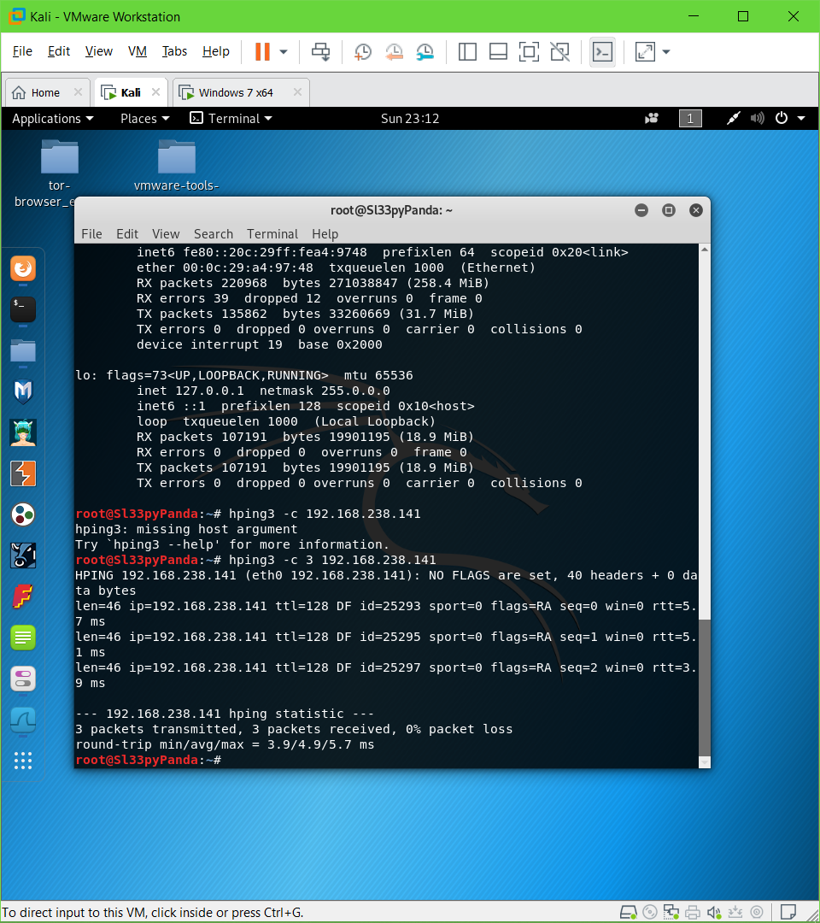

Hping3 –scan 1-3000 –S 192.168.238.141 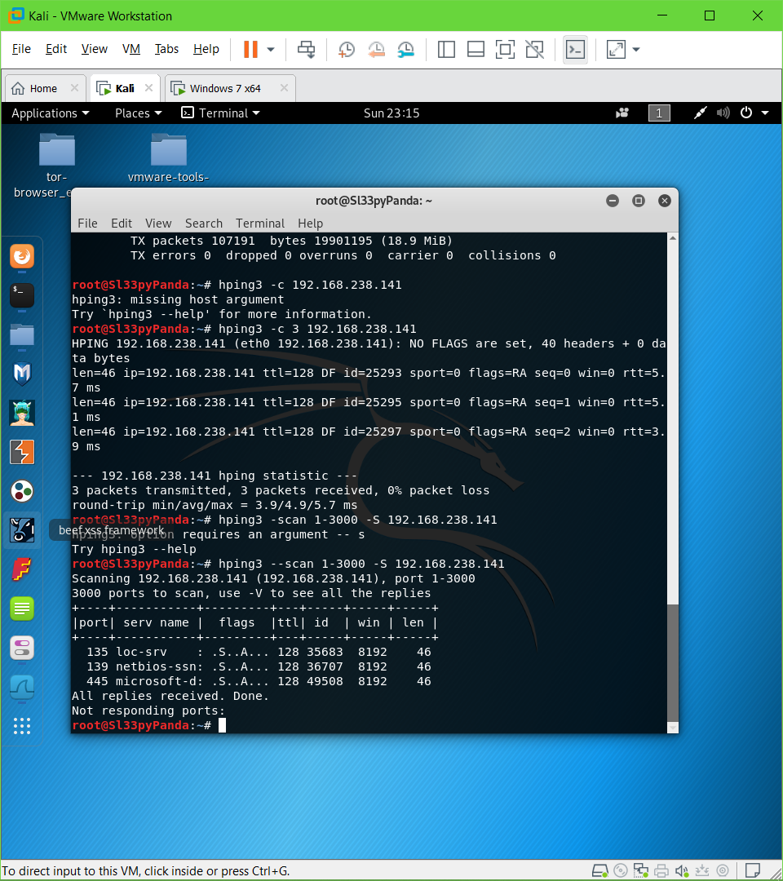

Hping 192.168.238.141 –udp –rand-source –data 500

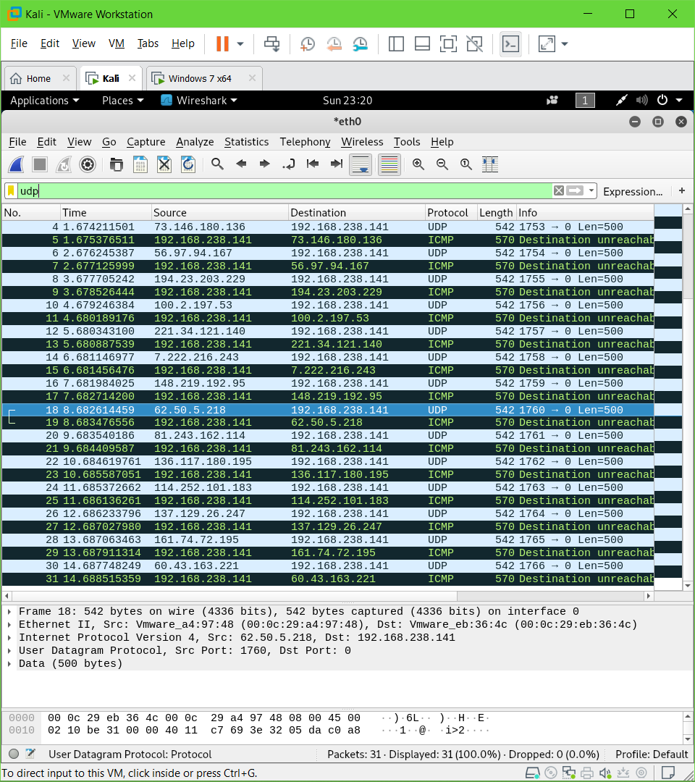

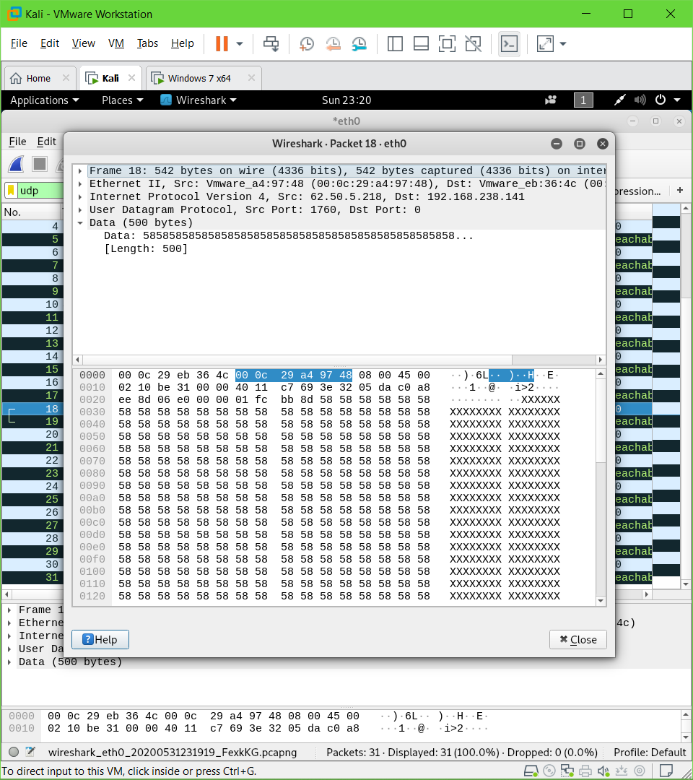

Hping3 –S 192.168.238.141 –p 80 –c 5

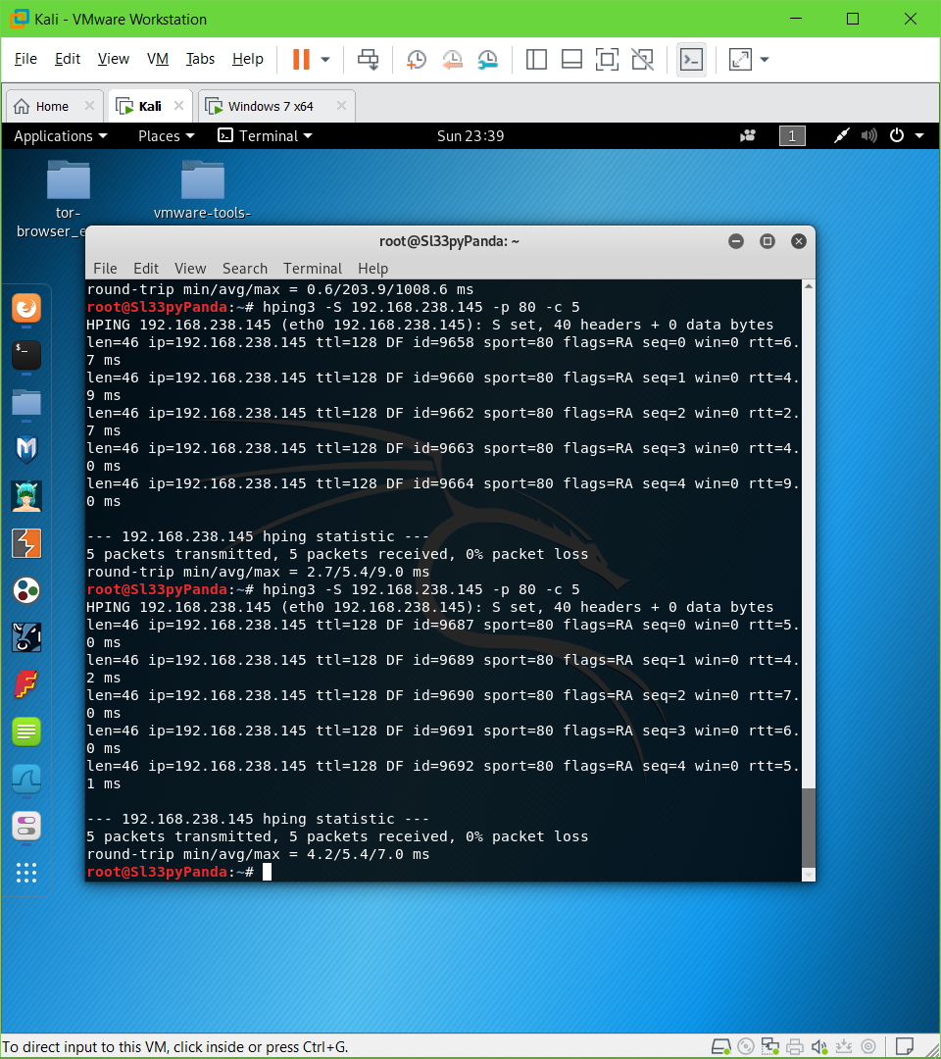

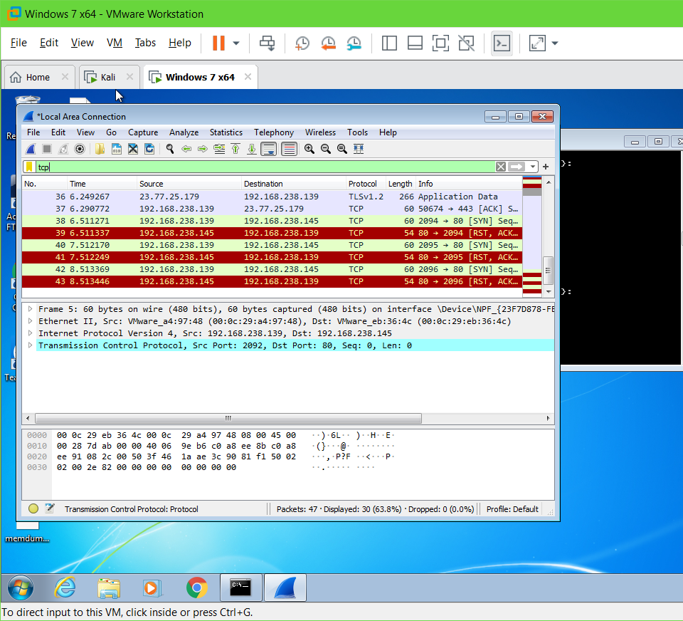

Flooding with 800k+ packets

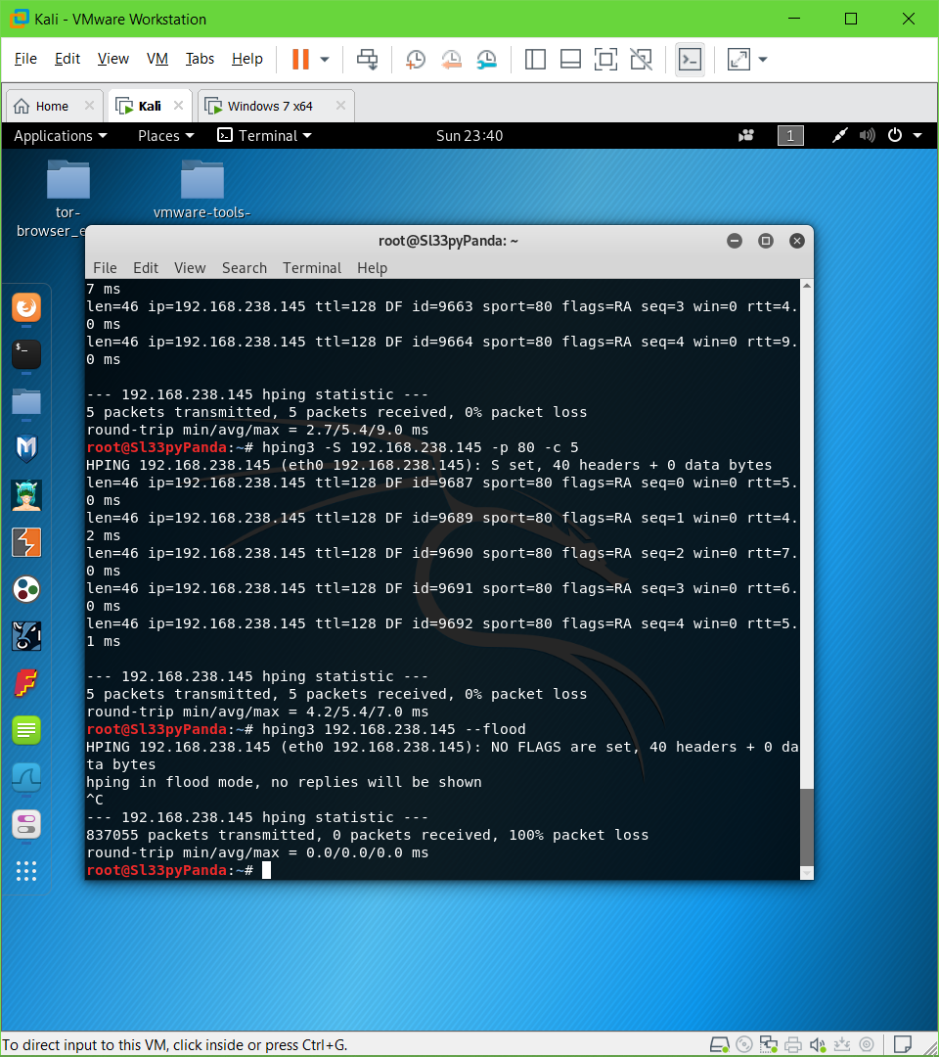

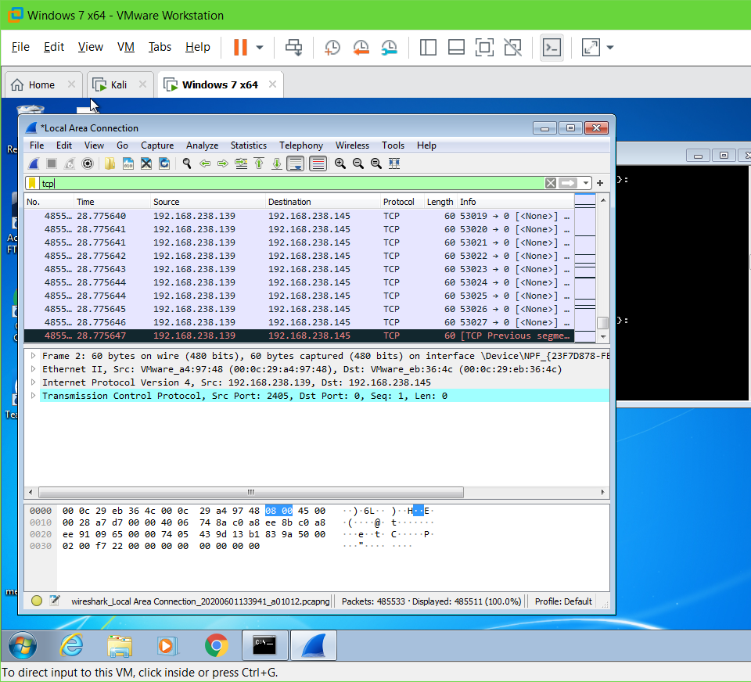

**Lab 2: Scanning the Network Using thr Colasoft Packet Builder**

Install ColaSoft

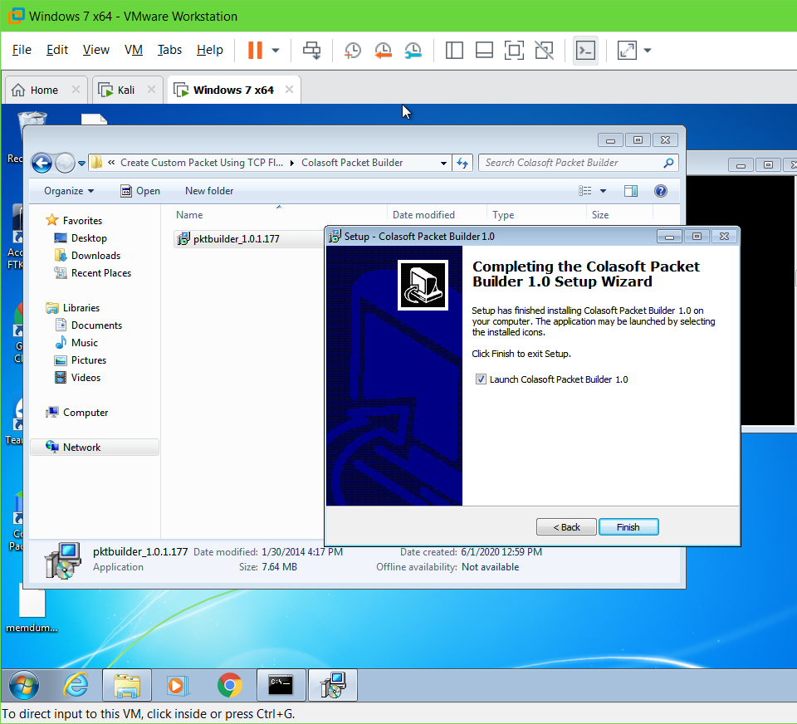

Select Adapter

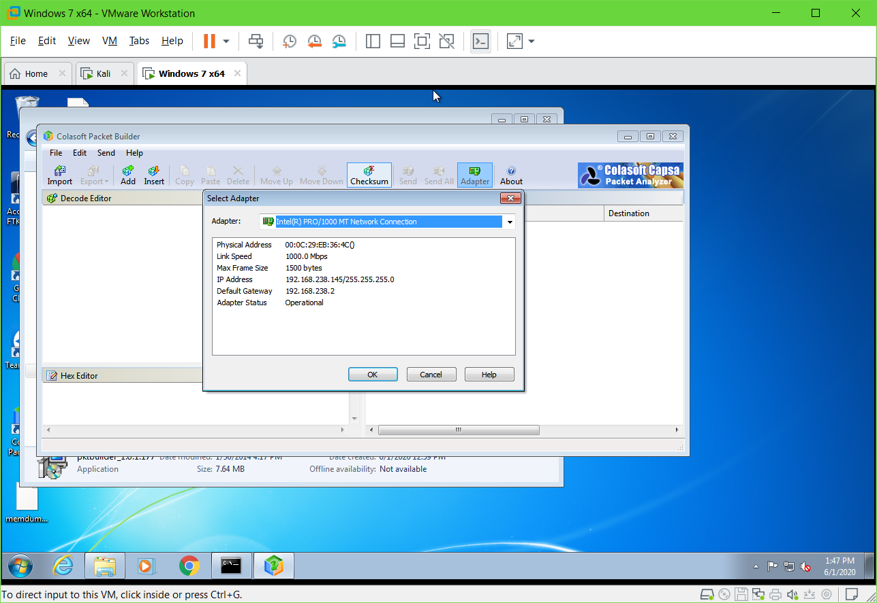

Add arp packet time 0.1

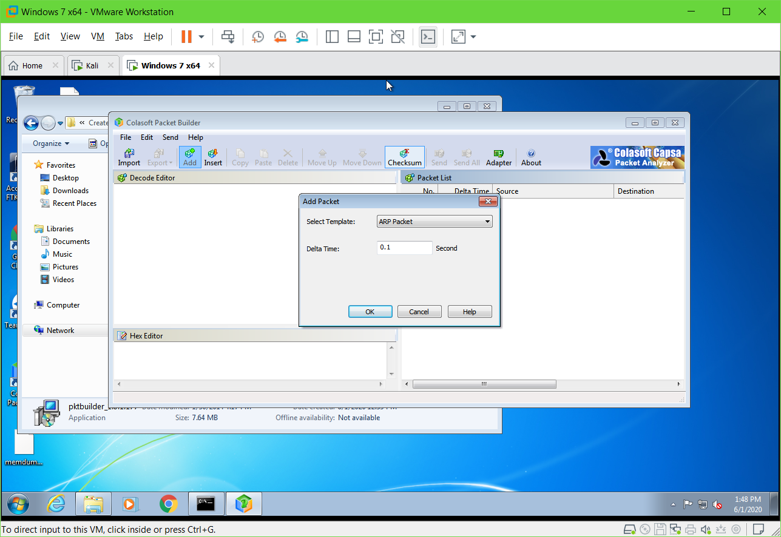

Added packet

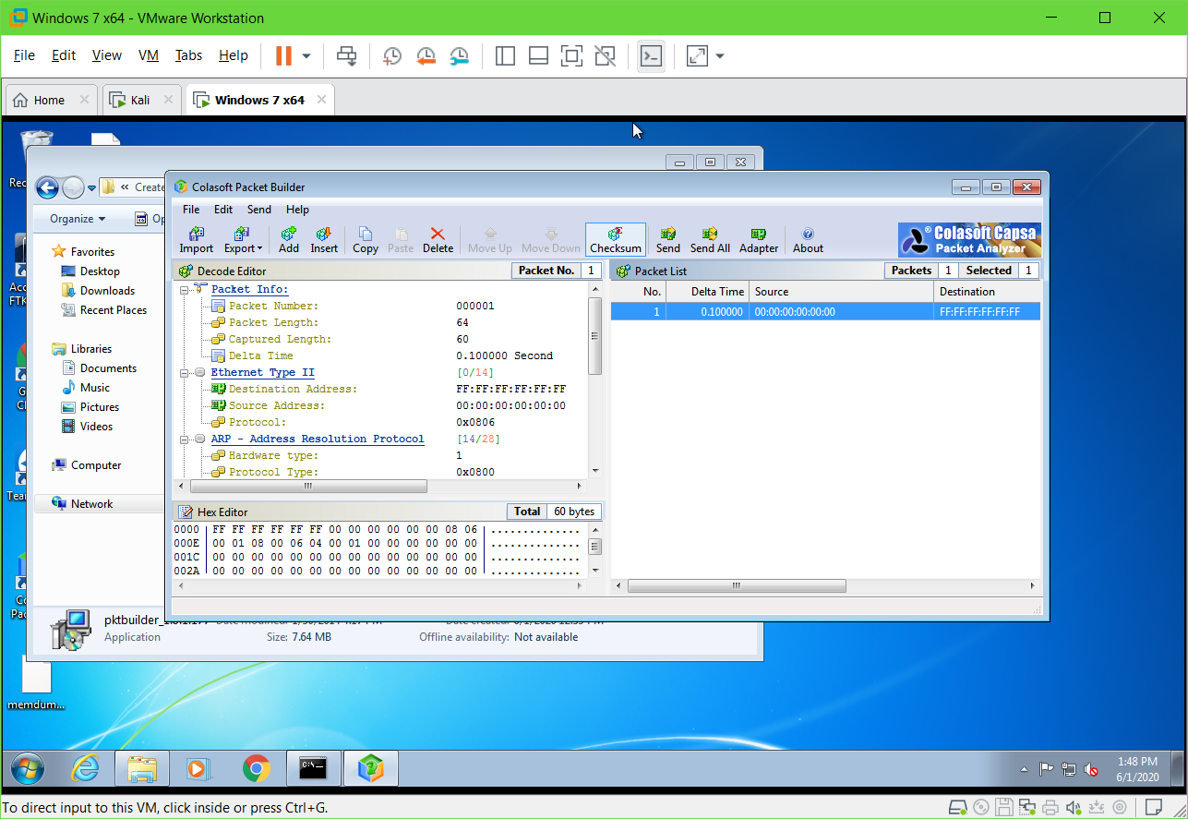

Send all in Burst mode

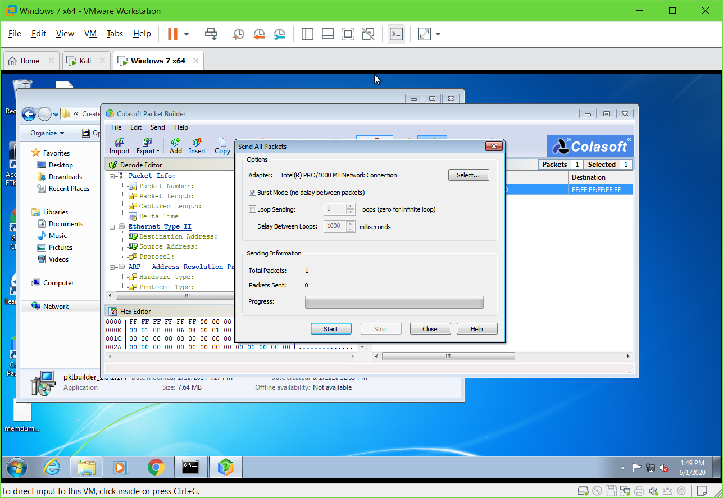

Done

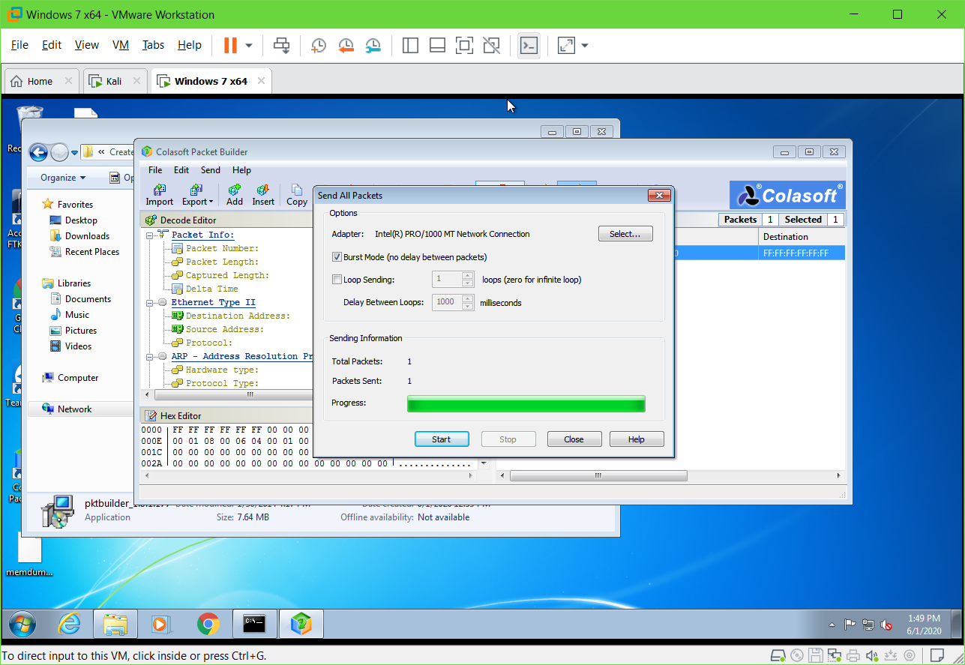

Save for future use

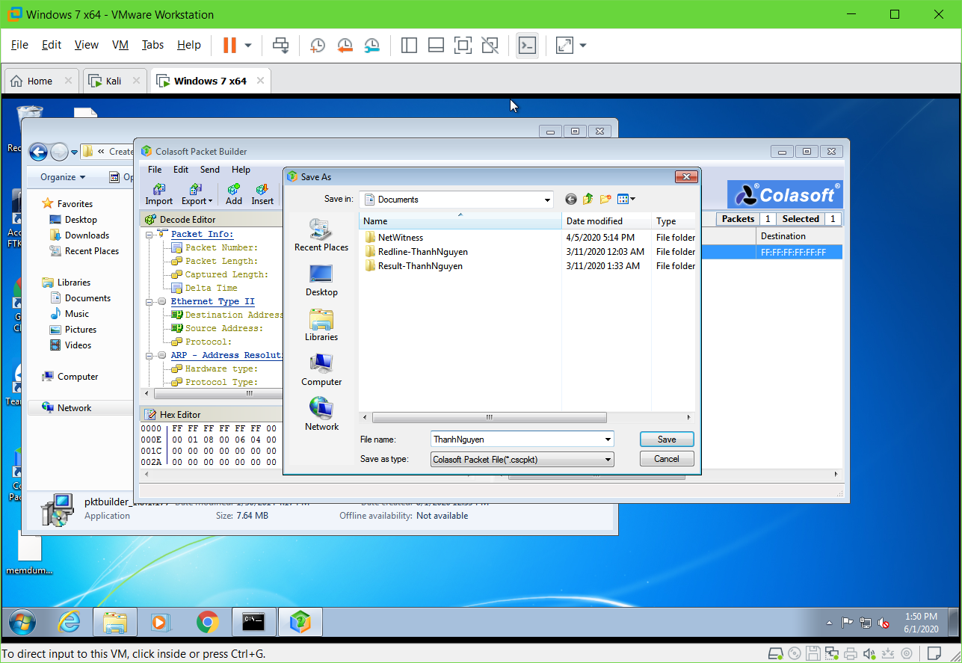

**Lab 3: Basic troubleshooting using MegaPing**

Install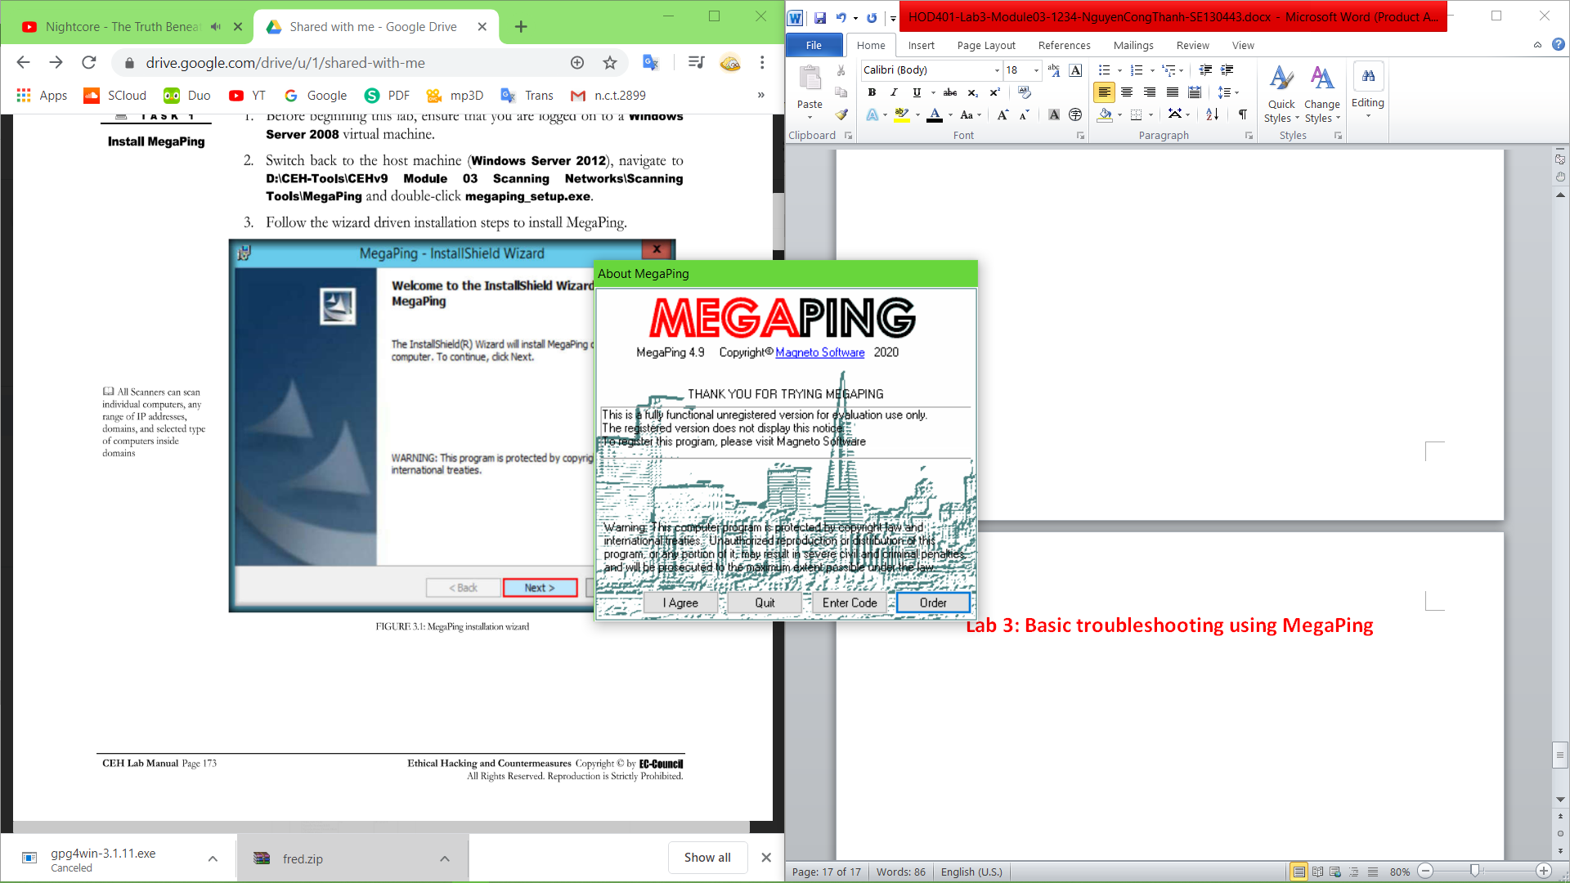

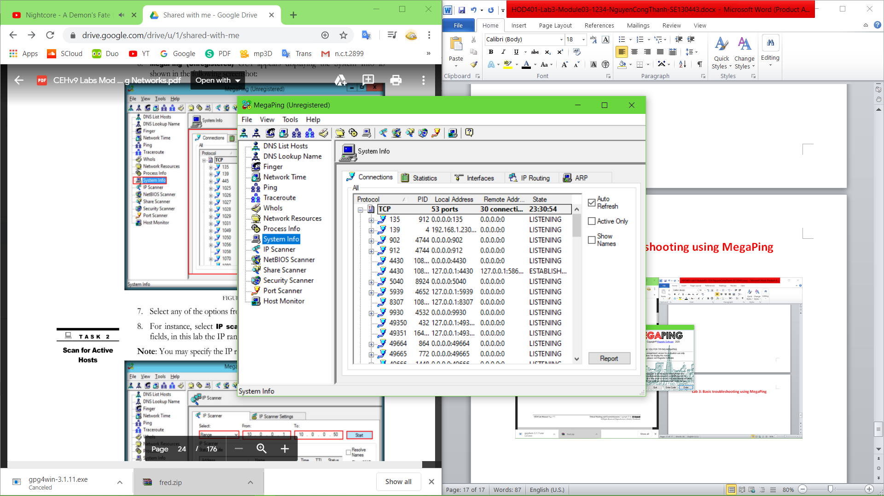

Scan in range

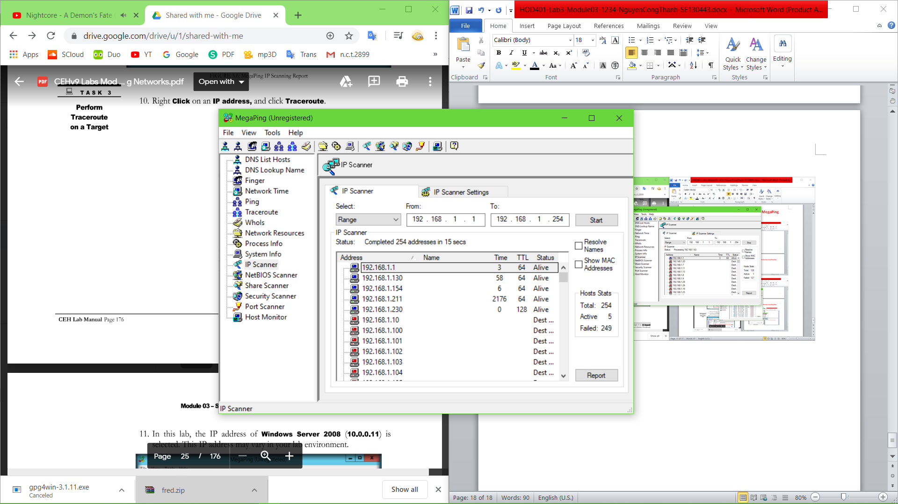

Traceroute

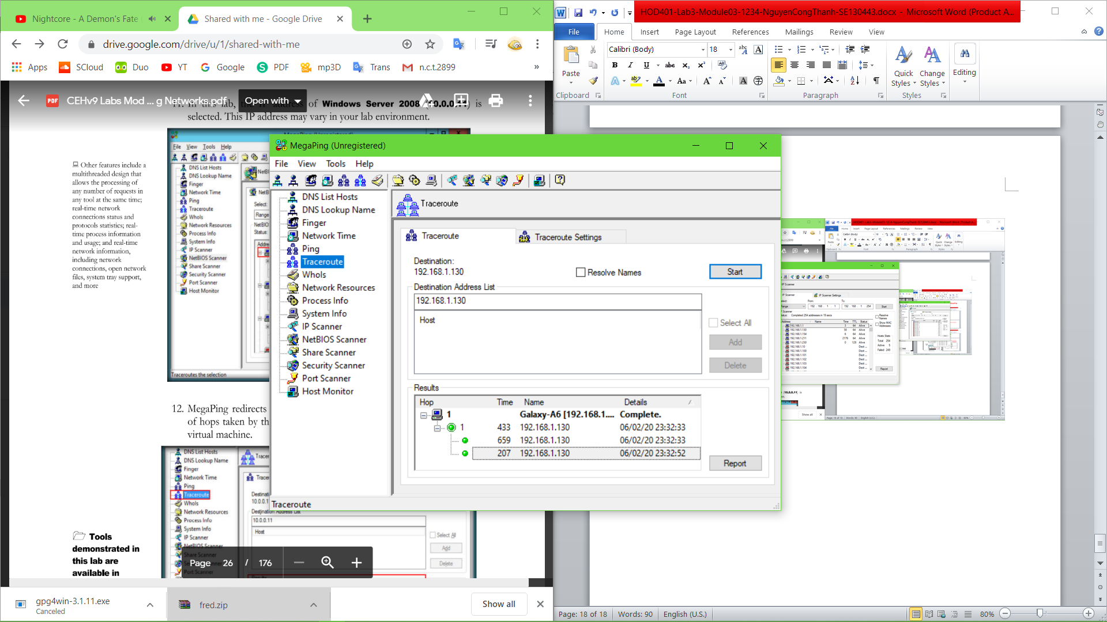

Port scanning

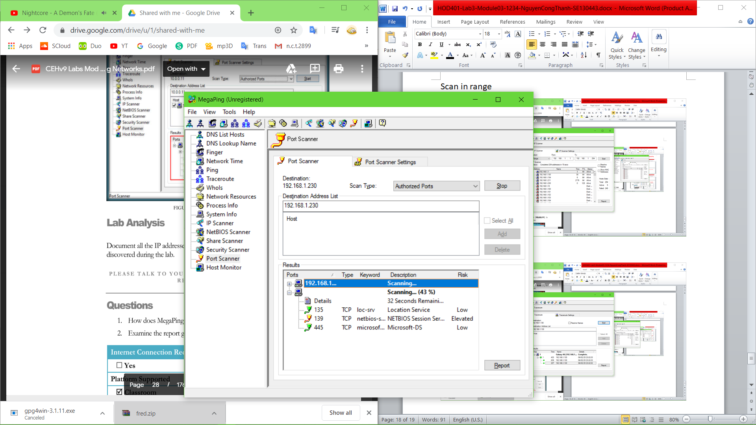

**Lab 4: Understanding Network scanning using nmap**

Nmap-zenmap

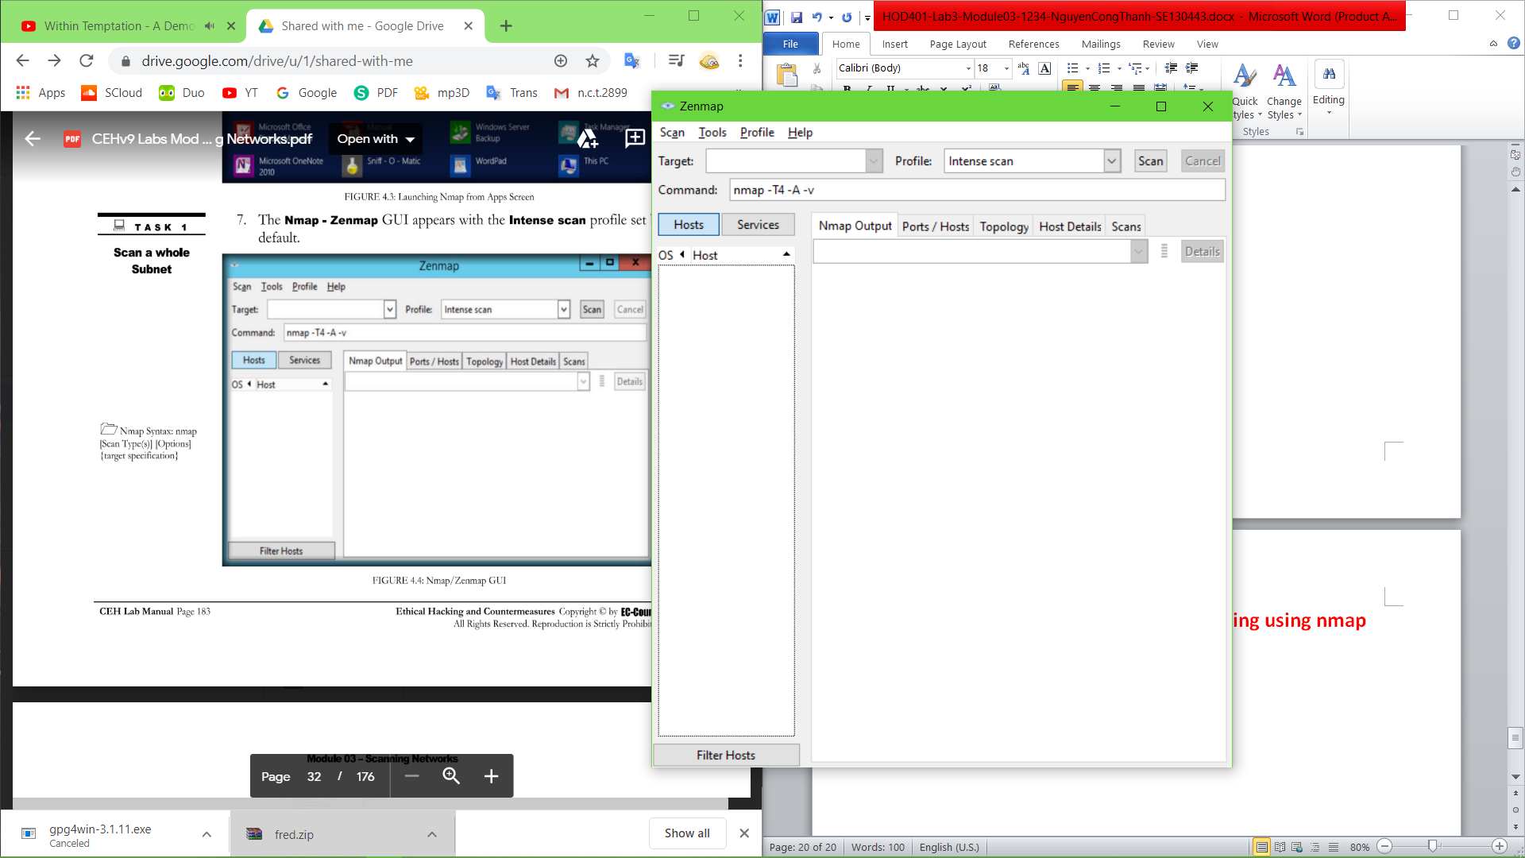

Start a scan

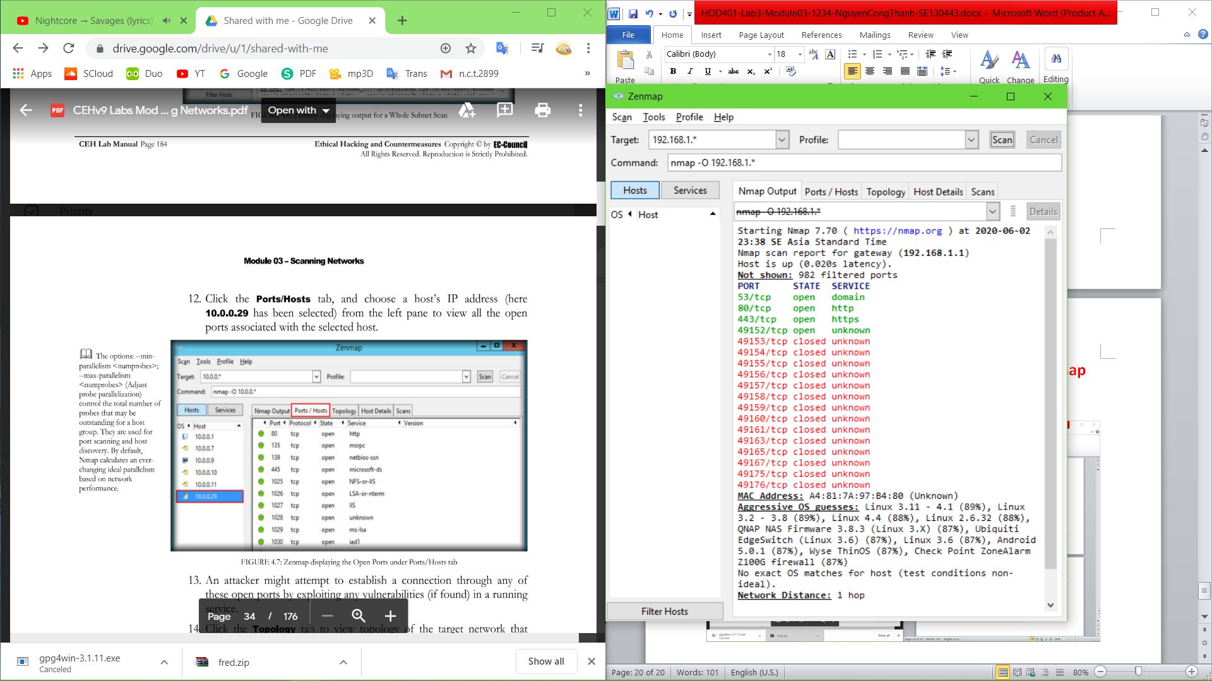

Topology fisheye : 1 host only

